*EXPERIMENT NO. 3:-*

*AIM:* Design a door bell using push button.

*APPARATUS:* one Arduino Board, one breadboard, one BUZZER, connecting wire, resistors – 10 k Ώ, pushbutton.

*CIRCUIT DIAGRAM:*

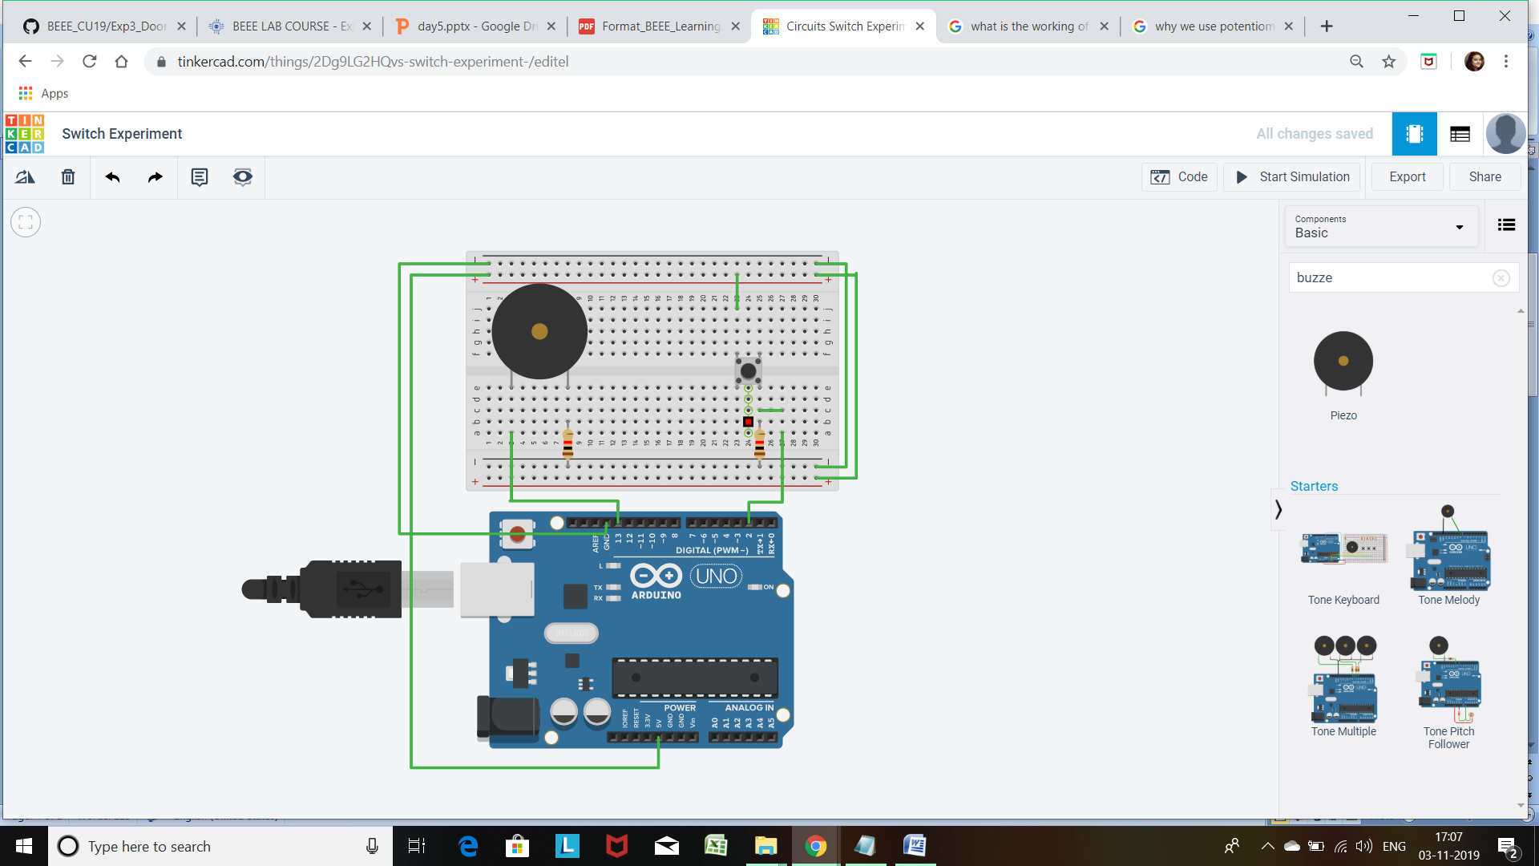

*THEORY:*

*Concepts Used:-*

Here we have used the concepts of SWITCH. When we press the switch the circuit becomes continuous and the digital pin reads a high .When it reads high we make the Doorbell work.

*Learning and Observations-* The learning which came from the experiment was that how a switch works and how we can connect a Doorbell to an Arduino and make it work.

*Problems and Troubleshooting:*

* Due to the wrong connections of the buzzer with the arduino the buzzer was not working.

By observing the cathode and anode terminal the connection was corrected.

*Precautions:*

1. Checking the continuity of the current flowing through the circuit.
2. Resistance of the resistor should be correctly calculated for proper reading.
3. Buzzer should properly work.
4. The connections should be proper and appropriate.

*Learning Outcomes:*

By doing this experiment we learned how to make a buzzer work and control it .